Design Ideas and Concepts for gSKI
Jacob Crossman, Soar Technology

Following is an example of how we might want to interface with the gSKI (for example, in an SSI):

Initialization:

1. Create soar kernel object through a factory method. Can specify single or multithreaded at this time. Ex:

SoarKernel* pSK = SoarKernel::Create(MODE_SINGLE_THREAD);

2. Create an agent. The production file, input link structure file and output link structure should be specifiable (optionally) at creation time. Ex:

SoarAgent* pAgent = pSK->CreateAgent(“Agent1”, “MyProductions.soar”);

3. Construct the input and output links:
a. Specify data files containing I/O link definition OR
b. Specify this definition through the link object interface

Ex:

pAgent->ConstructIOLinks(“IOLinksDescriptionFile.txt”);

OR

// The callbacks are optional, or could be specified separately.
// The extra parameteris “bucketsize” (how much change before notifying agent)
InputLink* pIL = pAgent->GetInputLink();
pIL->AddItemInt(“vehicle.radar.range”, 10, MyRadarRangeCallback);

OutputLink* pOL = pAgent->GetOutputLink();
pOL->AddItem(“weapon.missile.amram”, arrayOfEnumValues, MyAmramCommandCallback);

4. Attach callbacks to IO links. (Would like this to be done through a data specification, but that would require some type of introspection or object/function database for the simulation). Ex:

InputLink* pIL = pAgent->GetInputLink();
pIL->AddCallback(“vehicle.radar.range”, MyRadarRangeCallback);

// Here we register a single callback for ALL missile types (the subtree of the output link
// would be passed as a parameter to the callback)
OutputLink* pOL = pAgent->GetOutputLink();
pOL->AddCallback(“weapon.missile”, AllMissilesCallback);

5. Attach callbacks to the kernel (again, it would be nice to specify these through a data file, or have it happen automatically. Ex:

pSK->AddCallback(“CallbackName”, MySoarCallback);
pSK->RemoveCallback(“CallbackName”, MySoarCallback);

6. Create the GUI (if desired). Attach the GUI to the agent(s) it should monitor. Ex:

ImprovedTSI* pTSI = ImprovedTSI::Create(pAgent, MODE_SINGLE_AGENT);
pTSI->Init();
pTSI->Run();

Run:

Option A: Simulation update loop calls back agents and tells them to run for N decision cycles (can do this through the kernel to run ALL agents). Ex:

// … inside of the run loop or a simulation update callback
// Run one decision cycle (this would do the I/O too)
pSK->RunAllAgents(1);

OR

// Right now might not be possible, even if it makes sense
pAgent->Run(1);

Option B: Simulation spins off each agents as a separate thread. Ex:

// … inside of the soar worker thread’s entry function
pSK->RunForever();

I/O:

From the client side, this is just a set of callbacks into the simulation. For example:

Input can be pushed into the kernel as follows:

pAgent->GetInputLink()->SetValFloat(“vehicle.radar.range”, 35.0f);

And/Or, it can be monitored by the gSKI through a callback as in:

// Example input callback handler for radar
class RadarRangeMonitory: public IInputCallback
{
public:
virtual string HandleInputUpdate(InputLink* pIL)
{
// Input link passed in is always a sub-tree of
// rooted at the location you registered the callback.
pIL->Clear();
pIL->SetValFloat(“range”, m_fCurRange);
}
virtual bool IsChanged()
{
// Tell system if the value has changed (can be more efficient,
// this just shows the concept)
if(GetSimulation().GetRadarRange() != m_fCurRange)
{
float fOldRange = m_fCurRange;
m_fCurRange = GetSimulation().GetRadarRange();
return (m_fCurRange == fOldRange)? true: false;
}
}
private:
float m_fCurRange;
};

Output can be done through simulation “pull,” i.e. the simulation decides when it wants to know about commands and asks for command values explicitly. Ex:

OutputLink* pOL = pAgent->GetOutputLink();

// Looping,…
for(it = pOL->Begin(); it != pOL->End(); ++it)
ProcessCommand(*it);

// Knowing what you want,…
int pOL->GetValFloat(“weapon.missile.amram.count”);

OR, you can register a callback (makes sense most of the time). Ex:

// Example output callback handler
class WeaponCommands: public IOutputCallback
{
public:
virtual HandleOutput(OutputLink* pOL)
{
// Output link passed in is always rooted at
// the location that your callback was registered.

// if you have a variable number of params,…
for(it = pOL->Begin(); it != pOL->End(); ++it)
ProcessParam(*it);

// if expect certain parameters
int nNumToFire = pOL->GetValFloat(“missile.amram”);
}
};

Modules and Data Flow

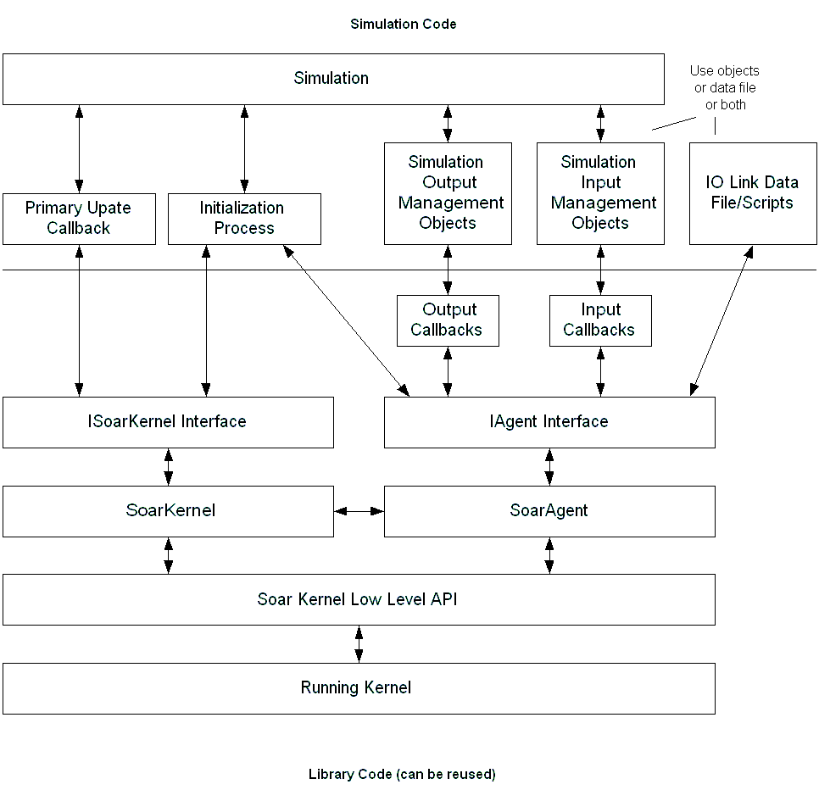
Figure 1: Primary Modules or Component Collections in System

Responsibilities of the Simulation

There will always have to be some simulation specific code. Ideally, this would consist only of an IO description data file (mapping inputs and outputs to data files), or a small script. However, that type of data-driven interface is difficult to achieve, and may not meet the needs of every simulation.

In a traditional connection to the gSKI using C++, most of the work on the simulation end will be in creating callbacks for the input and output links. The best solution in most cases will be to create a wrapper object around some collection of data (e.g. a radar wrapper) that is responsible for updating a particular part of the input link. Depending on the efficiency desired, these wrappers could simply be proxies for function calls into the engine, or they could cache data or do data manipulation as desired.

Responsibilities of the gSKI

The main responsibility of the gSKI is to encapsulate the simulation from all Soar idiosyncrasies, and reduce the number of steps necessary to execute the basic integration functions. Particular responsibilities include:

1. Wrapping the C level interface to increase encapsulation
2. Providing more structure, and simpler access to the agent’s input and output
3. Provide a clear and abstract interface layer between the agents and the simulation
4. Relieve the integration coder from having to manipulate low-level soar kernel code.
5. Provide a fixed interface, behind which the kernel can change without effecting existing connections to simulations.

The gSKI must manage the synchronization of the soar IO link and the world. It must also handle details of agent initialization and management at the low level.

Data Flow

Most of the data flow occurs through the IAgent and the ISoarKernel interfaces. This abstracts the simulation side code from the internal details of the gSKI code, and makes it easy to swap out one implementation and replace it with another. The interfaces also make the dividing line between the simulation and the kernel very obvious.

The simulation has four primary interface points with the soar kernel. For each of these interface points some simulation specific code must be written. Ideally, this could be done through introspection and some simple scripts. But, for now, it must be done in C++.

1. The update loop hook. If the simulation is going to run synchronized with the kernel, the simulation must provide an update callback during which the soar agents can run 1 or more decision cycles. If the soar agents are running as a separate thread, this hook is not needed.
2. The initialization hook: All simulations will require this hook. The simulation must initialize the kernel, rhs functions, any agents, the agent’s input/output link structure and callbacks, and any GUI components. It is the ideal solution that this is the only code the simulation side needs to write.
3. The input management objects/callbacks: Simulations that use the “polling the simulation” input strategy (see below) will need to register input callbacks to hook the gSKI with the simulation. Simulations using “gSKI as listener” will need to create code to push data to the agents when it changes in the simulation. This code will require interfacing through the IOLink interface, but that detail is left out of the diagram.
4. The output management objects/callbacks: Simulations will need to map output from the agent to callbacks, process the data and send it to the simulation. Otherwise the simulation will have to iterate through the list of waiting commands every simulation update. Again, this requires interaction with the IOLink interface not shown in the diagram.
5. (Optionally) IO Link Data File: It would be very nice to build the IO link through a data file or simple script. In this case, the primary data flow for building up the input and output link would consist of the reading and parsing of the data file or script. The file would describe the structure of the IO links and register attachments to the simulation (this is not usually possible in C/C++ where introspection is minimal).

IO Strategies

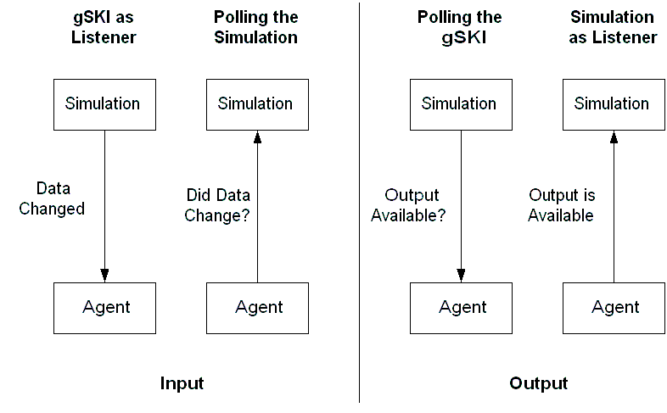

There are at least four different strategies that can be used to update the IO links: two for the input link and two for the output link. They displayed in the diagram above.

1. gSKI as listener (input): In this method, the simulation calls back the agent and tells it when something in the world changes as soon as the change occurs.
When to use: When the simulation does not change much between decision cycles of the agent.
Advantages: Communication between simulation and agent can be minimized. No attention paid to items that have not changed.
Disadvantages: If simulation is updating much more quickly than agents (as when the gSKI is run as a separate thread), the IO link may be updated much more often than it is sampled by the agent.

2. Polling the Simulation (input): In this method, the gSKI uses callbacks to request new inputs from the simulation on each decision cycle. Actual data transfer is minimized by asking each item if it has changed before actually calling a method to set the value.
When to use: When the simulation data changes as often or more often than the frequency of decision cycles of the agent.
Advantages: The simulation just needs to expose “get” methods (less work than managing data change events). Data transfer occurs only when the agent is ready to use it.
Disadvantages: If the simulation is updating slowly, or if the simulation data doesn’t change much or often, the system wastes time checking all input items.

3. Polling the gSKI (output): In this method, the simulation explicitly requests output commands from the gSKI whenever it is ready to process them.
When to use: The best place to use this is when the simulation can only handle input at only a single point or callback.
Advantages: The simulation doesn’t have to be interrupted with data changes. For simulations that are not real-time, executing output commands at any time the agent desires is not always feasible.
Disadvantages: Output commands may be not be handled when the agent desires. This may cause the agent to delay other decisions. The simulation code must iterate through and manage the entire output link.

4. Simulation as listener (output): In this method, the simulation listens to the agent and is notified immediately when an agent outputs a command or information.
When to use: Most of the time. This method is especially useful in real-time simulations where the agents are running in a separate thread.
Advantages: The simulation gets commands as soon as they are output, so the simulation appears more responsive. Each callback only has to handle a small portion of the output link.
Disadvantages: If the simulation cannot handle interruption from the agent, the output callbacks will have to queue messages. In that case it is best to use “Polling the gSKI” which lets the agent queue the commands.

Note: The system should not require any of these methods and should allow the gSKI integrator to decide how it is best to handle input and output on an item by item basis if necessary.
Structures:

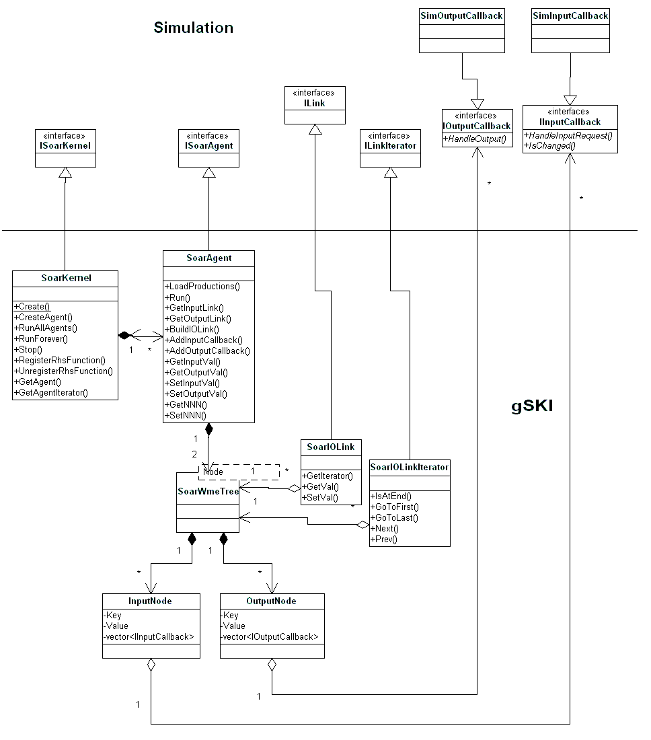

The dividing line in the diagram is the interface between the gSKI and the simulation system. In this design, the dividing line is the class interfaces shown above the line. These interfaces do not have any functions listed at this time because the functions they would provide are currently whatever is shown in their derived class. As an added bonus, the system would be convertible to a COM/CORBA system fairly easily with this model.

SoarKernel:

It would be nice to make this object go away and just deal with agents. However, there are some things that are shared among agents (like RHS) and we need an object that represents the agent collection. This is what the SoarKernel is. Primary responsibilities include:

1. Management of agent instances. This includes creating, storing, providing access to, and destroying, agents.
2. Registering RHS functions. (Many of these should be provided in a default library.)
3. Run the main the decision process and serve as an entry point for a soar execution thread.

SoarAgent:

The SoarAgent object is the primary interface between the simulation and soar. Its primary responsibilities include:

1. Management of the input and output links
a. Callback registration, unregistration
b. Input and output link construction
c. Mapping of soar input/output WMEs to simulation callbacks and data items.
d. Regulation of IO updates (controlling update rate, etc)
2. Management of agent knowledge (adding productions,etc)
3. Handling agent configuration (note the GetNNN and SetNNN methods intended to represent configuration changes to the agents).
4. Registering and managing agent specific callbacks.

SoarWmeTree, SoarIOLink and SoarIOLinkIterator:

SoarWmeTree encapsulates the agent’s input output links. It presents these links as hierarchical tree structures similar to an operating system’s file system. An agent will hold exactly two SoarWmeTrees, one for the input link and one for the output link. The goals of this object are to store the I/O link data efficiently in space and time and to present a simple interface to the user for accessing the data (e.g. without having to manipulate low-level nodes).

SoarIOLink encapsulates accessing the input or output link as a whole (or as a sub-tree). It contains methods for adding and removing items based on key/value pairs and for obtaining iterators into the link. The primary reason for separating this object from SoarWmeTree is to allow sub-trees of SoarWmeTree to be treated as whole trees.

SoarIOLinkIterator encapsulates a position within an IO link. It is able to move between items in an IO Link and to retrieve the key/value pair at its current position.

The simulation does not see SoarWmeTree; it only sees the SoarIOLink and the SoarIOLinkIterator.

Callbacks (IOutputCallback, IInputCallback):

IInputCallback provides an interface by which the gSKI can callback the simulation when it is ready to populate the input link. A callback can be registered for a single item of the tree, or for a subset of the tree. In either case, the gSKI queries the callback by calling IsChanged to determine if it is even necessary to update that item or set of items. The HandleInputRequest method is responsible for actually putting values on the input link through the IOLink interface.

IOutputCallback provides an interface by which the simulation is notified of agent output. A callback can be registered for a single output item or for a subset of the output link tree. Multiple output callbacks can be registered for a single item or sub-tree. The HandleOutput method is responsible for reading the output link for agent commands and executing them in the simulation.

Low level issues to think about:

* How to handle I/O link keys. Obviously strings of some sort are convenient. Should we use symbolic keys??? Does this make IO management too complex?

* Data management in the callbacks. If data is stored in the callbacks, we could have three copies of some data in the system (one in the callback, one in the gSKI and one in the kernel). We don’t want to do this. The extra copy is only needed in the input callback for checking in “IsChanged.” If we don’t ask “IsChanged” we can do the check in the gSKI, but this might be inefficient. This really boils down to: “who should handle these change details?” I think the gSKI should, but if we can make it flexible enough to work both ways, that would be even better.

* Multithreading of the gSKI (i.e. the gSKI in a separate thread) should be supported. This will require locking, unlocking and reference counting in the agents. All should be invisible to the end user, however (except reference counting in a multithreaded app).

* Helper classes, templates and method should be created to make the simulation side code even simpler than what is described here. For example, most callbacks may take the same form, so provide a template for these similar callbacks.

* It may be nice to register a simple, regular function as a callback. It shouldn’t be too hard to bend the design to handle this case also.

* There is always an issue of what to pass callbacks that are registered for more than one item. Should you pass them all items they are watching (even if only one changed) or just the changed items? And should it be called multiple times when multiple items change, or only once with all parameters passed simultaneously?

